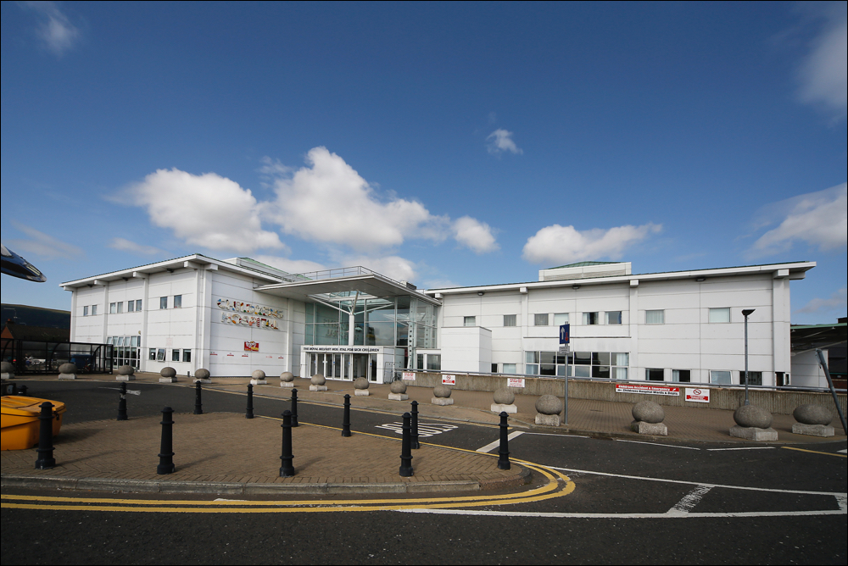
PCCS-SG AUTUMN MEETING
10 SEPT 2025
Clinical Skills Centre, Elliott Dynes Building, Royal Victoria Hospital, 274 Grosvenor Rd, Belfast BT12 6BA
IN-PERSON EVENT ONLY
Register online: https://www.pccsbelfast25.com/register
WEDNESDAY 10 SEPT 2025
NIHR-supported Paediatric Critical Care Incubator event
RESEARCH TRAINING & CAREER DEVELOPMENT
For any member of the MDT wanting to be research-involved, junior or senior
10.15 – 10.30 | Registration
10.30 – 10.35 | Welcome, PCC Research Incubator | Ram/Silvia Giampieri
10.35 – 10.50 | How I built my research career | Prof Danny McAuley
10.50 – 11.05 | Preparing a research CV | Emma Alexander
11.10 – 11.25 | Preparing a conference abstract | Fiona Frame
11.30 – 11.45 | Research careers – personal viewpoint | Prof Bronagh Blackwood
11.45 – 12.10 | Research opportunities for PCC staff | Ram/Lyvonne
12.15 – 12.30 | Summary and close | Ram/Silvia Giampieri
12:30 – 13.00 | LUNCH

PCCS-SG RESEARCH MEETING
What’s on-the-go, what’s up-and-coming and what to-look-out-for in UK PICU research
13.00 - 13.05 | Welcome/Introductions, PCCS-SG Update | Ram, Lyvonne
13.05 – 13.10 | National PPI group | Julie Menzies
RESEARCH UPDATES (10 + 5 min): What’s on-the-go
13.10 – 13.20 | GASTRIC trial | Lyvonne Tume
13.25 – 13.35 | PRESSURE trial | David Inwald
13.40 – 14.30 | PIVOTAL platform trial | PIVOTAL team
14.30 – 14.45 | BREAK
14.45 – 14.55 | Immunomodulation in PICU | Luregn Schlapbach
15.00 – 15.10 | Pressure injury | Joseph Manning
15.15 – 15.25 | Palliative care needs | Lara Bunni
15.30 – 15.40 | PICNIC | Nazima Pathan
15.45 – 15.55 | Optimising nutrition | Lyvonne Tume
16.00 – 16.10 | STARSHIP | Shruti Agrawal
NEW IDEAS (10 + 5 min): Up for Discussion
16.15 – 16.25 | Neonatal respiratory failure | Jon Lillie
16.30 – 16.40 | Implementation of trial findings | Emma Alexander
16.45 – 16.55
16.55 – 17.00 | Round up | Ram, Lyvonne

