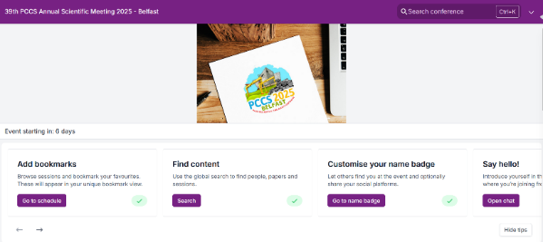
The Oxford Abstracts app will allow for great networking opportunities at PCCS ’25. In order to setup your account login to oxford abstracts.

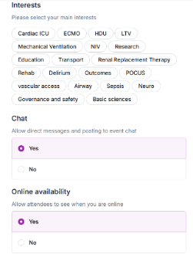
Click on ‘customise your name badge’

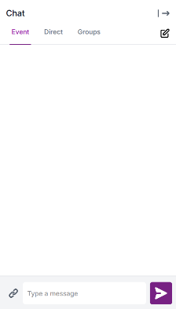
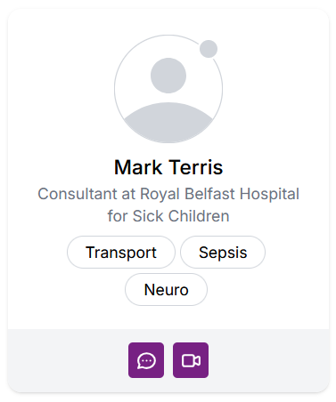
You can then set your profile picture, interests and allow others to send you messages in event chat.

This will allow you to search through attendees, to send people a direct message and for other attendees to message you. There are also options to create group chats through the chat bar, or even send event wide messages to all conference attendees.

The Oxford Abstracts app also allows you to view the programme with ease and plan your days.
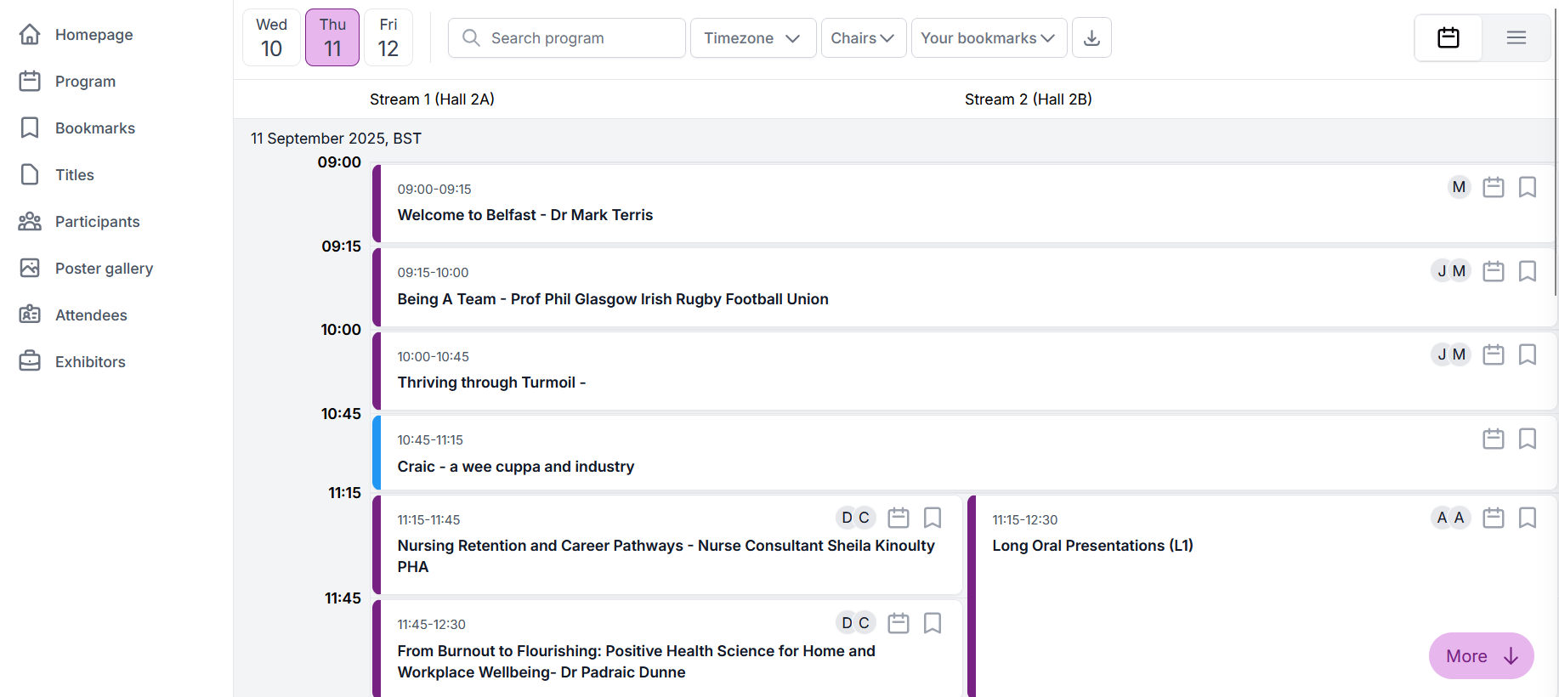
Clicking Programme on the menu will show you all the excellent sessions happening each day.
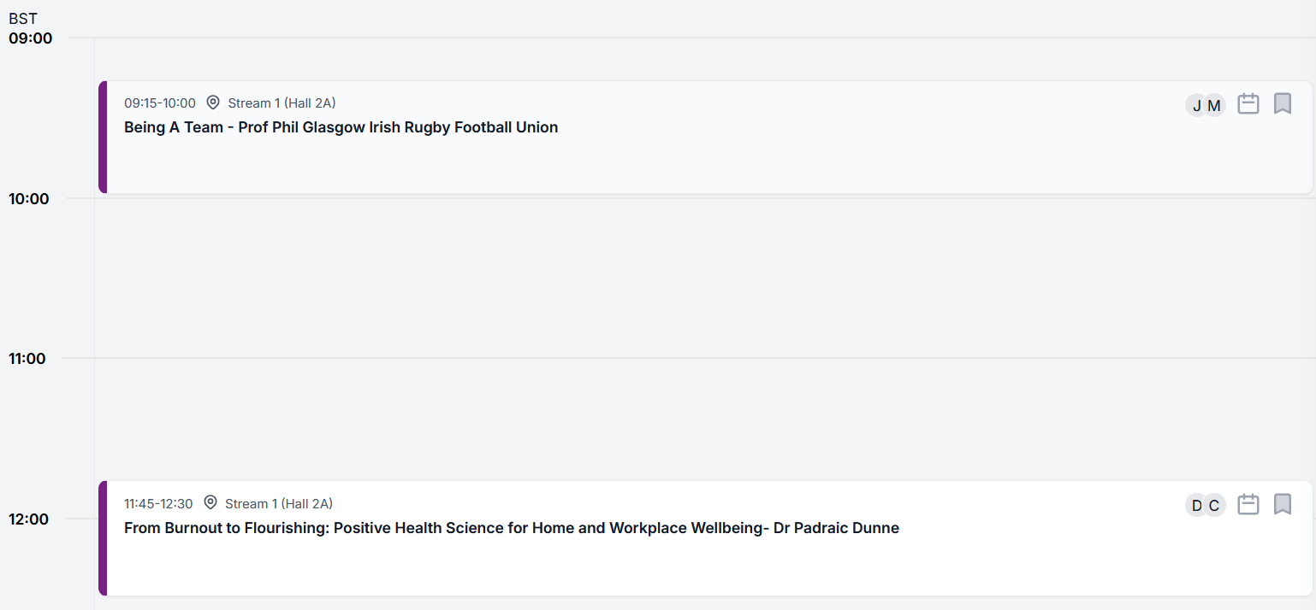
See any session that particularly excites you? Click the bookmark tab and Oxford Abstracts will highlight that session for you.

